High-Level Functional Requirements Specification
for Jal Rekha SVS PHE Modules – GHAN 2.0 Integration
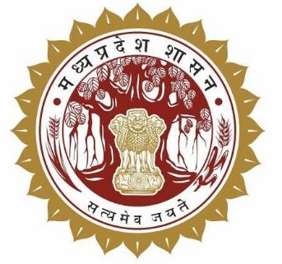
PHE Single Village Scheme (SVS) – Jal Rekha to GHAN 2.0

Madhya Pradesh State Electronics  Development Corporation (MPSeDC)  State IT Center, 47-A, Arera Hills,  Bhopal, M.P. – 462011 |  | Prepared for the Public Health Engineering  Department (PHED), Government of Madhya Pradesh  Phone: +91-755-2518300  URL: www.mpsedc.mp.gov.in
High-Level FRS | Document Version 1.0 (Draft) | October 2026

Table of Contents

Document Control 3
1. Background 3
2. Purpose and Scope (Integration) 3
In scope (Integration): 3
Intended outcomes 4
3. Reference to Existing (Base) System 4
3.1 Existing Components (for reference only) 4
3.2 Reason for Integration into GHAN 2.0 4
4. Integration Requirements 5
Reference screen – Jal Rekha login 5
5. Scope of Work – Functional Requirements 5
FR-01: User Management Module on Web (15 days) 5
FR-02: Asset Mapping Module (15 days) 6
FR-03: Data Visualisation (10 days) 6
FR-04: Parinam Module – Tap Connection Validation (15 days) 6
FR-05: Dhara Module – Water Quantity (18 days) 6
FR-06: Nirmal Module – Water Quality (15 days) 6
FR-07: Sahbhagita Module – Community Participation (15 days) 6
FR-08: Jal Samadhan – Unified Complaint and Grievance Module (20 days) 7
Complaint registration 7
Processing and tracking 7
Escalation and monitoring 7
Reference screens – Jal Rekha base platform 7
FR-09: GHAN 2.0 Integration (12 days) 10
6. Functionality List 10
7. Stakeholders and Role-wise Access 11
7.1 Stakeholders and User Roles 11
7.2 Role-wise Access Matrix 12
8. Methodology & Approach 12
9. Indicative Timeline 12
10. Deliverables 13
11. Requirement Yet to be Shared by Department 13

Document Control
Field | Value
Document Title | FRS_Jal Rekha_PHE_GHAN Integration – High-Level Functional Requirements Specification
Project | Jal Rekha and PHE – Single Village Scheme (SVS) and GHAN 2.0 Integration
Prepared For | Public Health Engineering Department (PHED), Government of Madhya Pradesh
Prepared By | MPSeDC – Business Analysis / Project Team
Base Document | High-Level Functional Requirements Specification – Jalrekha and PHED SVS and GHAN 2.0 Integration (source FRS, Jalrekha PHE)
Version | 1.0

1. Background
The Jal Rekha platform is the Government of Madhya Pradesh water-supply monitoring platform, available as a web application and as a native Android mobile application. It is being extended to the Public Health Engineering Department (PHED) for Single Village Schemes (SVS). The SVS functionality is organised into six field-facing modules, together with user management, data visualisation and a unified complaint module:
- Jal Samadhan – Unified complaint and grievance module for Handpumps, SVS and MVS.
- Nirmal – Water quality (sample collection and testing).
- Parinam – Household tap connection (FHTC) validation, with AI support.
- Dhara – Water quantity (meter reading).
- Asset Mapping – Geo-mapping of SVS assets.
- Sahbhagita – Community participation through Implementation Support Agencies (ISA).
GHAN 2.0 is the Department's application built on a different technology stack, Flutter, whereas Jal Rekha uses Android as its native technology stack. Maintaining the two applications side by side would give PHE users two apps, two logins and two codebases for one set of field workflows.

2. Purpose and Scope (Integration)
This document defines, at a high level, the functional requirements for integrating the Jal Rekha SVS PHE modules into the GHAN 2.0 project, so that all modules are delivered on the single GHAN 2.0 (Flutter) technology stack, on both mobile and web.

In scope (Integration):

- GHAN 2.0 integration with Jal Rekha (at both Mobile and Web) :- GHAN 2.0 has different technology stack which need to be redirected and bring all modules on same technology stack of Jal Rekha. (for now we will redirect from jal Rekha to GHAN app)
- Jal Rekha has 2 login where Jal rekha department login and other PHE department login. And where PHE will have 2 user login of PHE SVS and GHAN user.
- AI Integration :- FHTC Parinam Tap connection module developed in Jal Rekha AI features can be used in SVS PHE and GHAN module integration.

Intended outcomes
- One PHE field application on a single technology stack (Flutter) instead of parallel native Android and Flutter apps.
- Role-based access with a single, consistent user and scheme master.
- Reuse of Jal Rekha AI capability (FHTC Parinam tap connection validation) within GHAN 2.0.
Note: Because Jal Rekha is a native Android application and GHAN 2.0 is Flutter, the Android screens cannot be embedded directly. The modules are re-implemented in Flutter in GHAN 2.0, reusing the existing Jal Rekha backend services and business rules wherever possible. Until each module is available in GHAN 2.0, users are redirected from Jal Rekha to the GHAN app (see Section 4).

3. Reference to Existing (Base) System
The table below summarises the base systems on which the scope of work in Section 5 is delivered.

3.1 Existing Components (for reference only)
S.No. | Component | Technology | Current Status / Role
1 | Jal Rekha web portal | Web application | Department login and other PHE department login; Dhara and Nirmal web modules already exist; Parinam web reports available
2 | Jal Rekha mobile app | Native Android | Field functions: asset capture, meter reading, sample collection, tap connection validation
3 | GHAN 2.0 web portal | GHAN 2.0 stack | Target platform for the integrated PHE modules
4 | GHAN 2.0 mobile app | Flutter | Target mobile platform; modules to be integrated here
5 | FHTC Parinam AI feature | AI-assisted validation | Developed in Jal Rekha; to be reused for SVS PHE and GHAN integration

3.2 Reason for Integration into GHAN 2.0
Aspect | Jal Rekha | GHAN 2.0
Mobile technology stack | Native Android | Flutter
Integration consequence | Android screens cannot be reused in Flutter | Modules to be integrated with GHAN 2.0
Interim approach | Redirect user to GHAN app | Receives the redirected user

4. Integration Requirements
These requirements apply across all modules.
- Single technology stack: Jal Samadhan, Nirmal, Parinam, Dhara, Asset Mapping and Sahbhagita are integrated into the GHAN 2.0 project (Flutter), on both mobile and web.
- Interim redirection: until a module is live in GHAN 2.0, Jal Rekha redirects the user to the GHAN 2.0 app / portal for that module.
- Two login types in Jal Rekha: the Jal Rekha department login and the other PHE department login.
- Two user logins for PHE: PHE SVS user and GHAN user.
- AI integration: the FHTC Parinam tap connection AI features developed in Jal Rekha are used in the SVS PHE and GHAN modules.
- Common masters: User Master and Scheme Master are shared, so that role, scheme and village mapping is the same on both platforms.

Reference screen – Jal Rekha login
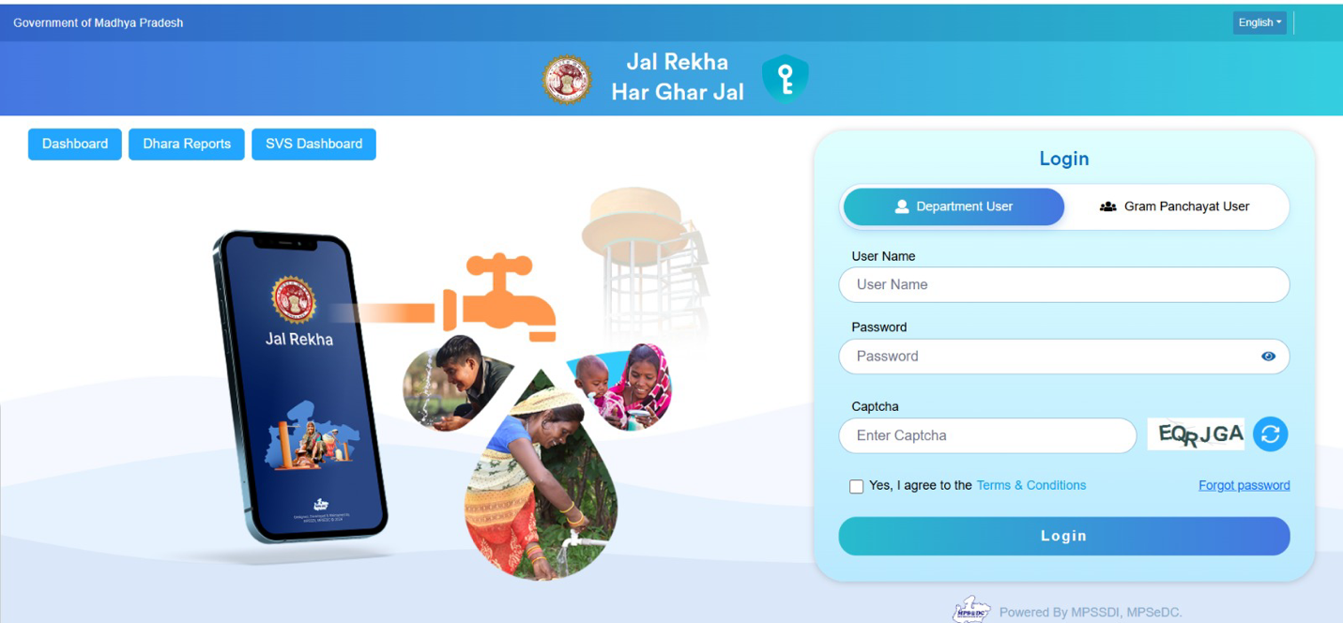
Figure 1: Jal Rekha login page (Department User / Gram Panchayat User)

5. Scope of Work – Functional Requirements
Requirements are arranged by module. Estimated development effort (in working days) is shown against each module and summarised in Section 9.

FR-01: User Management Module on Web (15 days)
- User registration.
- Role-based login for EE, AE, SE, TPI-A and TPI-TL with role-appropriate access.
- EE can assign schemes to users; EE can create users, and activate or deactivate them.
- Role-based menus, dashboards and data visibility (scheme, block, district, division).
- Import of User Master and Scheme Master supplied by the Department.
- Audit log of user creation, status changes and scheme assignments.

FR-02: Asset Mapping Module (15 days)
- Display and maintain already-mapped assets: distribution pipeline, OHT (overhead tank) and tubewell.
- Enable mapping of pending assets: sump well and pump line.
- Asset upload facility in the web portal.
- Capture asset geo-location and attributes through the mobile app.
- Link every asset to its scheme and village.
- Asset mapping report (scheme-wise, district-wise, status-wise: mapped vs pending) on the web application, with export.

FR-03: Data Visualisation (10 days)
- Scheme-wise and district-wise visualisation of SVS asset data.
- Map and chart views with drill-down from district to scheme to asset.

FR-04: Parinam Module – Tap Connection Validation (15 days)
- Mobile app function to validate household tap connections in the field, with AI integration.
- Integration with Samagra ID for beneficiary / user identification.
- Web module for report of validation status (validated, pending, not found) by scheme, village and district.

FR-05: Dhara Module – Water Quantity (18 days)
- Make the existing Jal Rekha Dhara web module available to PHE users (role-based).
- Mobile app for meter reading where a water meter is available (reading entry, photo capture, geo-tag, timestamp).
- Validation of readings; for example, a reading lower than the previous one is flagged.
- Web reports on consumption and reading status.

FR-06: Nirmal Module – Water Quality (15 days)
- Make the existing web module for water sample testing available to PHE users.
- Mobile app for geofenced sample collection from assets (collection allowed only within a defined radius of the asset).
- Sample collection from OHT, Tubewell and Beneficiaries.
- Record sample details, test results and status; flag results outside permissible limits.
- Web reports on sample and test status.

FR-07: Sahbhagita Module – Community Participation (15 days)
- Web and mobile modules for community participation activities.
- Scheme-wise mapping of ISAs using the list provided by the Department.
- Activity capture, monitoring and reports by ISA, scheme and district.

FR-08: Jal Samadhan – Unified Complaint and Grievance Module (20 days)
Jal Samadhan is incorporated as the single module for raising and tracking complaints for Handpumps, SVS and MVS, and is delivered within GHAN 2.0.

Complaint registration
- Citizen registration and OTP-based login.
- Complaint categories – Handpump: not working, low discharge, contaminated water, damaged platform. SVS and MVS: no supply, low pressure, pipeline leakage, quality issue, meter issue, others.
- Asset selection by map, asset ID or nearest-asset search; geo-tagged photo upload; location capture.
- Unique complaint ID generated for every complaint, whichever channel it comes from.

Processing and tracking
- Automatic routing to the responsible officer or team based on asset type, scheme and location. Handpump and SVS complaints go to PHED field functionaries; MVS complaints go to MPJN-designated officers.
- Assignment to technicians or field staff, with status updates, before and after geo-tagged photos, and maintenance or repair details.
- Real-time status tracking for the citizen, with SMS or WhatsApp notifications at registration, assignment and closure.
- Citizen feedback on closure, with the option to reopen a complaint.

Escalation and monitoring
- Time-bound, level-wise escalation; the escalation matrix and timelines are to be finalised with the Department.
- Dashboards for the ACS, MPJN, Engineers-in-Chief, SE, EE and AE covering complaints received, pending, resolved, escalated and breaching the timeline.
- Reports by district, scheme, asset type, channel, category and officer; export to Excel and PDF.
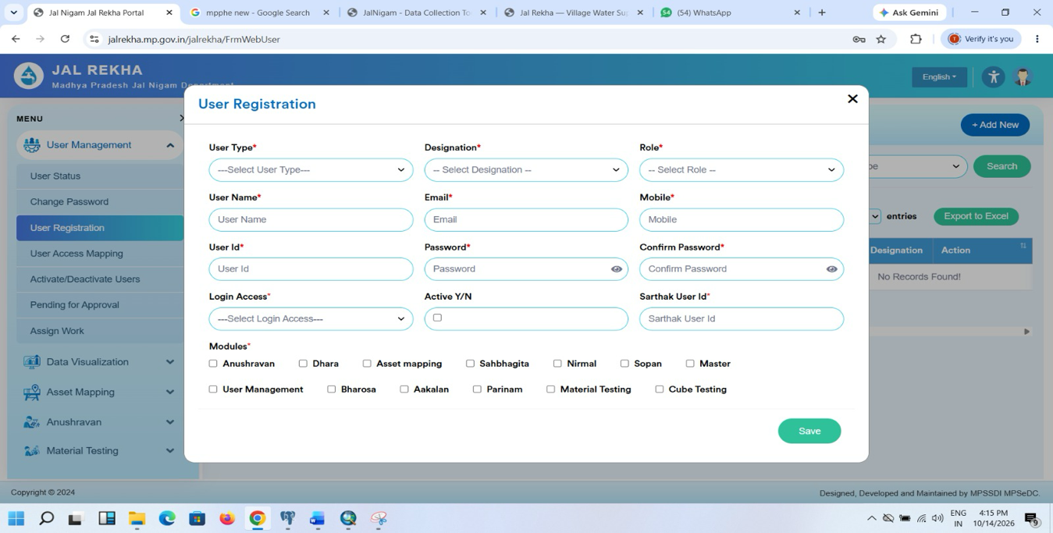
Figure 2: User registration with module-wise access (User Management)
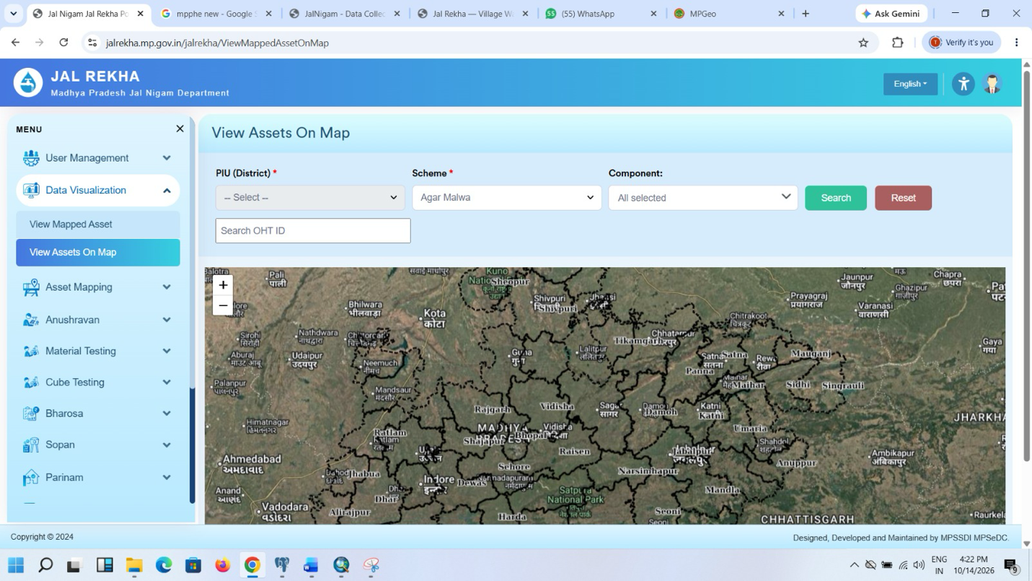
Figure 3: View Assets on Map (Asset Mapping and Data Visualisation)
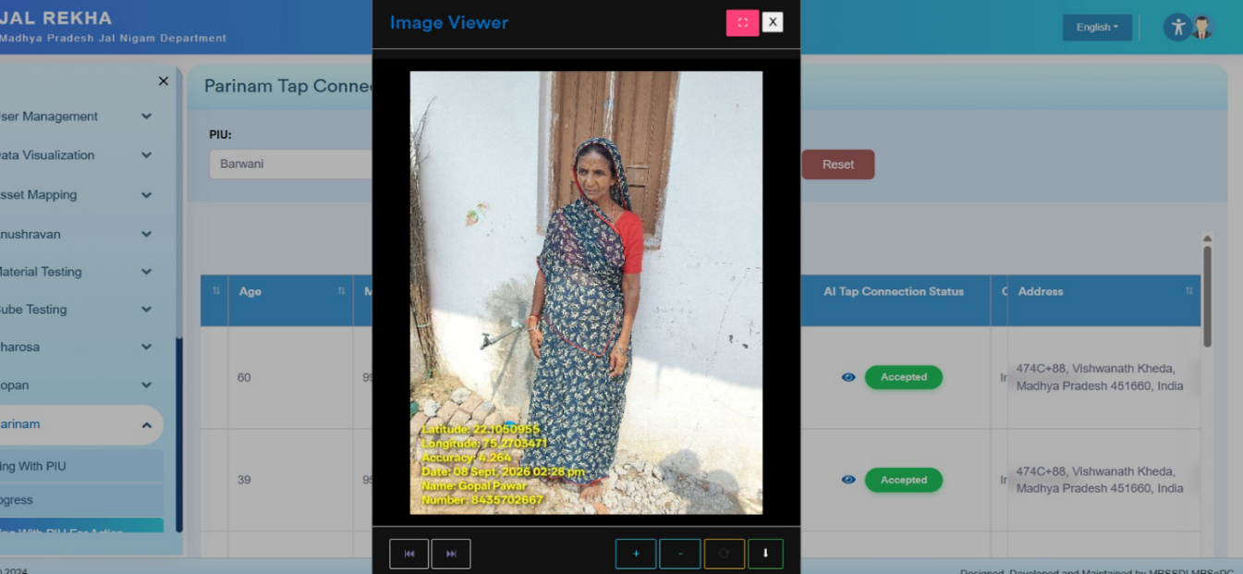
Figure 4: Parinam – tap connection validation report with photo viewer
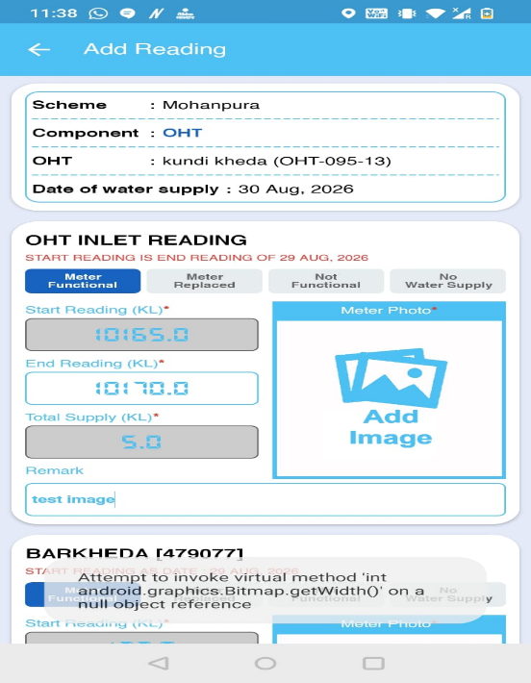
Figure 5: Dhara – mobile meter reading (OHT inlet reading)
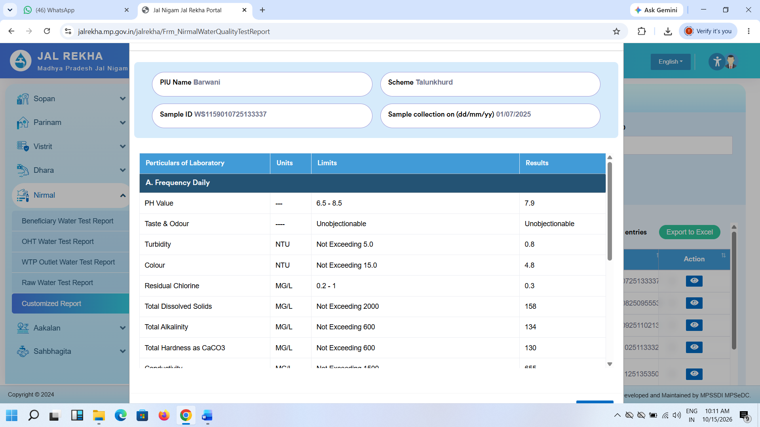
Figure 6: Nirmal – water quality test report
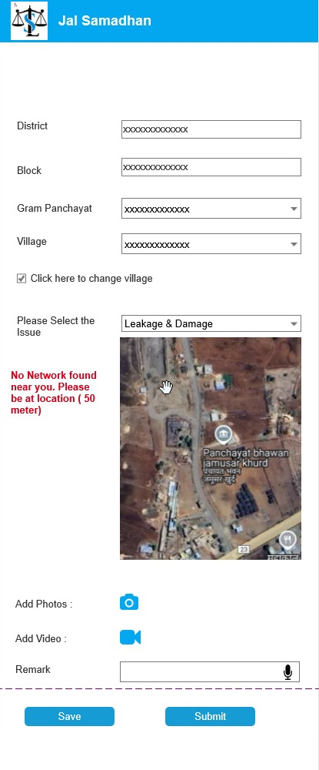 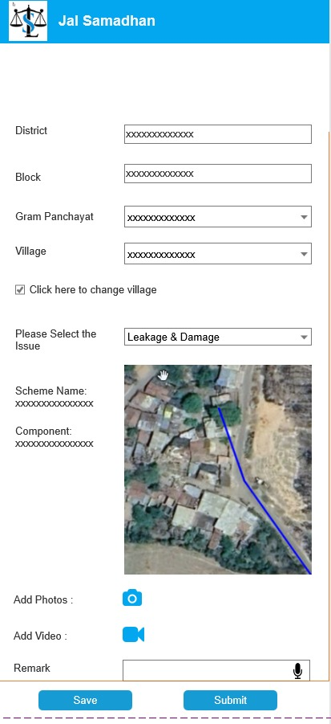
Figure 7:– Jal Samadhan

FR-09: GHAN 2.0 Integration (12 days)
- GHAN 2.0 web portal integration.
- GHAN 2.0 mobile app integration with the Jal Rekha app (redirection from Jal Rekha to GHAN).
- Re-implementation of the above modules on the GHAN 2.0 Flutter stack, with GHAN 2.0 integration starting in Phase 2 as Nirmal completes.
- Support for the two PHE user logins (PHE SVS user and GHAN user) and the two Jal Rekha login types.
- Reuse of the Parinam AI feature in the GHAN 2.0 module.

6. Functionality List
S.No. | Functionality | Reference | Delivery Phase
1 | User management on web | FR-01 | Foundation
2 | Asset Mapping | FR-02 | Phase 2
3 | Data Visualisation | FR-03 | Phase 2
4 | Parinam – tap connection validation | FR-04 | Phase 1
5 | Dhara – water quantity | FR-05 | Phase 1
6 | Nirmal – water quality | FR-06 | Phase 2
7 | Sahbhagita – community participation | FR-07 | Phase 1
8 | Jal Samadhan – complaints and grievances | FR-08 | Phase 1
9 | GHAN 2.0 integration | FR-09 | Phase 2

7. Stakeholders and Role-wise Access

7.1 Stakeholders and User Roles
Role | Description | Access Channel
EE (Executive Engineer) | Administers schemes and users | Web
AE | Monitoring and supervision | Web and Mobile
SE | Field-level supervision, asset and validation review | Web and Mobile
TPIA / TL | Third-party inspection agency staff and team leads | Web (to be confirmed – see Section 11)
ISA | Implementation Support Agency (Sahbhagita module) | Web and Mobile
Citizen | Raises and tracks complaints (Jal Samadhan) | Mobile (OTP login)
ACS, Engineers-in-Chief | Monitoring dashboards and escalation (Jal Samadhan) | Web

7.2 Role-wise Access Matrix
Module | EE | AE | SE | TPIA/TL | ISA | Citizen | Officers
User management | Yes | – | – | Yes | – | – | –
Asset Mapping | Yes | Yes | Yes |  | – | – | –
Data Visualisation | Yes | Yes | Yes | Yes | – | – | –
Parinam | Yes | Yes | Yes | Yes | – | – | –
Dhara | Yes | Yes | Yes | Yes | – | – | –
Nirmal | Yes | Yes | Yes | Yes | – | – | –
Sahbhagita | Yes | Yes | Yes | Yes | Yes | – | –
Jal Samadhan | Yes | Yes | Yes | Yes | – | Yes | Yes
Note: The module-wise access is indicative and is to be confirmed with the Department during detailed design.

8. Methodology & Approach
- Receive User Master, Scheme Master and ISA list from the Department.
- Detailed requirement confirmation per module, followed by Flutter design and development in GHAN 2.0, reusing Jal Rekha backend services.
- Phase-wise delivery with UAT, bug fixing and Department feedback after each phase.
- Go-live preparation, training and deployment at the end of each phase.

9. Indicative Timeline
Effort summary (working days of development effort):
# | Module | Effort (days)
1 | User Management | 15
2 | Asset Mapping | 15
3 | Data Visualisation | 10
4 | Parinam | 15
5 | Dhara | 18
6 | Nirmal | 15
7 | Sahbhagita | 15
8 | Jal Samadhan | 20
9 | GHAN 2.0 Integration | 12
 | Total effort | 135

Phase-1 | Phase-2
User Management | Asset Mapping
Parinam | Data Visualisation
Dhara | Nirmal
Sahbhagita, Jal Samadhan | GHAN 2.0 Integration (starts as Nirmal completes)
UAT, bug fixing and Department feedback | UAT, bug fixing and Department feedback
Go-live preparation, training, deployment | Go-live preparation, training, deployment

10. Deliverables
- Jal Rekha SVS PHE modules integrated in GHAN 2.0 (mobile and web) as listed in Section 6.
- Role-based user management with User Master and Scheme Master import.
- Reports and dashboards as described under each module.
- UAT support, training and deployment per phase.

11. Requirement Yet to be Shared by Department
- The Department provides the User Master and Scheme Master before development of each module.
- The Department provides the scheme-wise ISA list for Sahbhagita.
- Dhara mobile meter reading applies only where water meters are installed.
- Timelines are in working days of development effort, exclude Department-side delays in data or approvals, and exclude UAT.
- Channel access for TPIA / TL is to be confirmed: the role list shows Web while the user management requirement shows Mobile.
- The Jal Samadhan escalation matrix and timelines are to be provided by the Department.

